Isomers that have same molecular formula but different functional group are known as ______.
A. Structural Isomers
B. Functional group Isomers
C. Position Isomers
D. Metamers
ANSWER: B
Which functional group have similar general formula as ether?
A. Alkane
B. Alkyl Halide
C. Alkanol
D. Alkanoic acid
ANSWER: C
$C_{4}H_{8}O_{2}$ may have compounds that belong to __________.
A. Alkanoic acid and Alkyl alkanoate
B. Aldehyde
C. Alkanol and Alkanoic acid
D. Alkanoic acid
ANSWER: A
Glucose and fructose are _______.
A. Structural Isomers
B. Functional group Isomers
C. Position Isomers
D. Chain Isomers
ANSWER: B
What is the general formula for Aldehyde and Ketone?
A. $C_{n}H_{2n+2}O$B. $C_{n}H_{2n+2}O_{2}$
C. $C_{n}H_{2n}O$
D. $C_{n}H_{2n+1}O$
ANSWER: C
Which of the following isomer is not possible for \({C_4}{H_{10}}\)?
A. n-butane
B. Iso-butane
C. Neo-butane
D. None of these
ANSWER: C
How many chain isomers of heptane are possible?
A. 3
B. 6
C. 9
D. 12
ANSWER: C
The no. of isomers for ten number of carbon atoms are _______.
A. 85
B. 75
C. 65
D. 55
ANSWER: B
Which of the alkane molecules have chain isomers?
A. Alkane with two or more carbon atoms
B. Alkane with three or more carbon atoms
C. Alkane with four or more carbon atoms
D. All of these
ANSWER: C
Geometric isomerism is only observed in ______.
A. Alkane
B. Alkene
C. Alkyne
D. Alkyl halide
ANSWER: B
Why geometric isomerism is restricted to specific class of hydrocarbon?
A. Number of carbon atoms
B. Hybridization
C. Restriction in rotation between
D. All of these
ANSWER: C
What is the name of following compound?
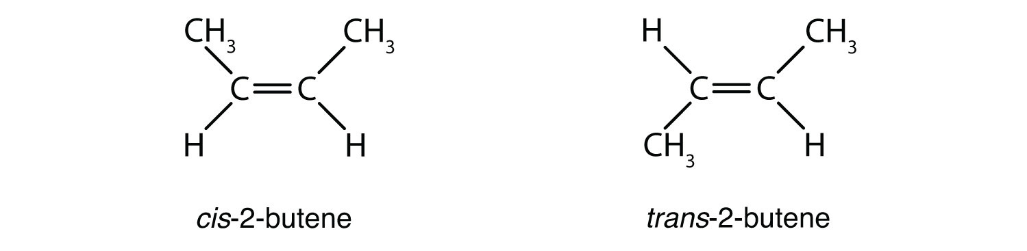
A. Cis-butene
B. Trans-butene
C. Cis-2-butene
D. Trans-2-butene
ANSWER: C
Which of the following name is suitable for the given compound?
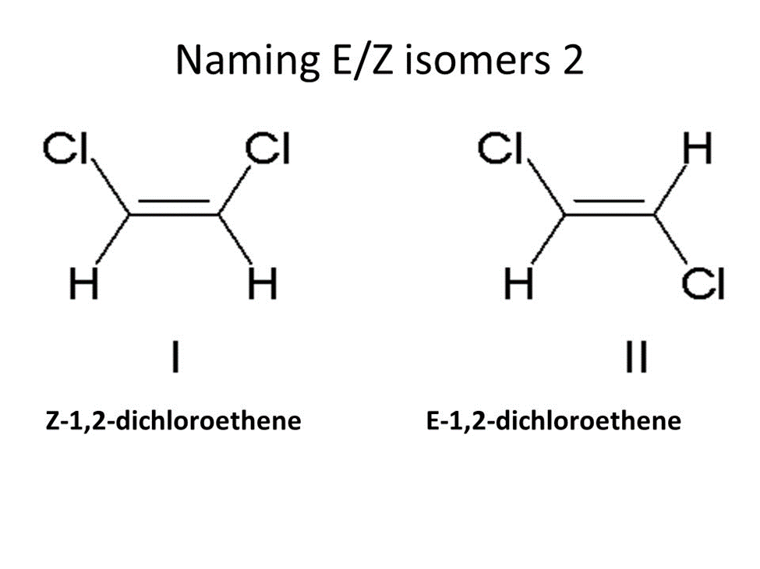
A. Cis-1,2-dichloroethane
B. Trans-1,2-dichloroethane
C. Cis-1,2-dibromoethane
D. Trans-1,2-diromoethane
ANSWER: A
Which of the following name is suitable for the given compound?
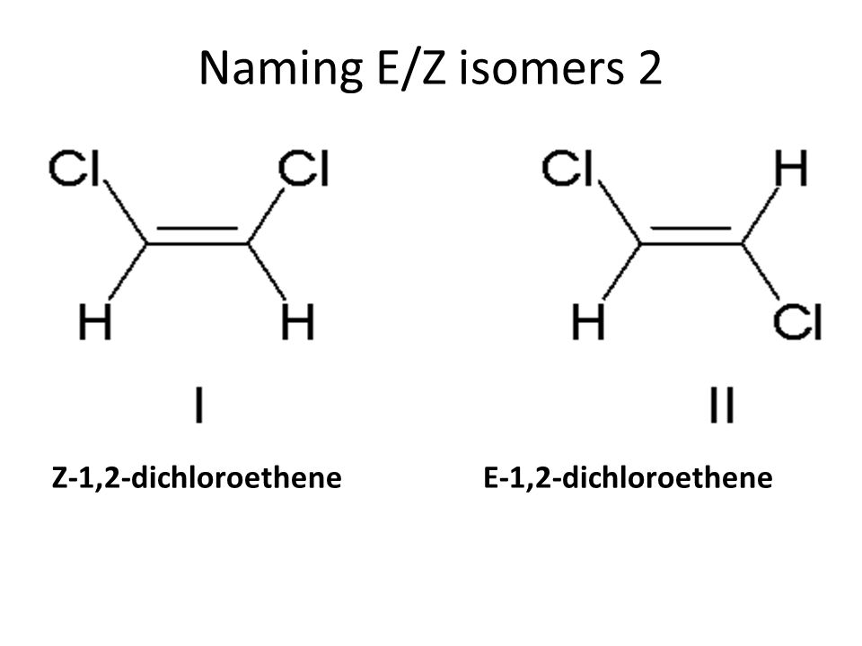
A. Cis-1,2-dichloroethane
B. Trans-1,2-dichloroethane
C. Cis-1,2-dibromoethane
D. Trans-1,2-diromoethane
ANSWER: B
Which of the following is not an example of trans isomers?
A. 
B. 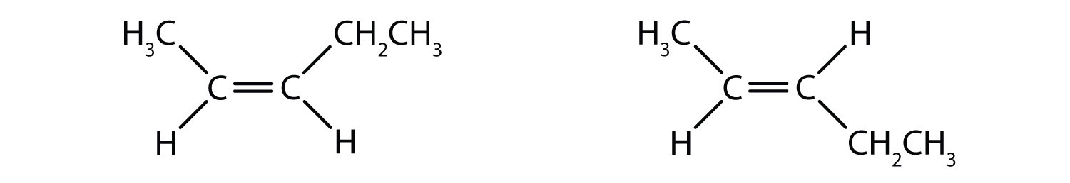
C. 
D. 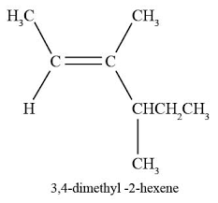
ANSWER: C

Isomers are the different organic compounds that have _________.
A. Same molecular formula but different molecular structures
B. Different molecular formula and different molecular structures
C. Different molecular formula but same molecular structures
D. Same molecular formula but same molecular structures
ANSWER: A
The number of possible isomers of $C_{4}H_{10}O$ are
A. 1
B. 2
C. 3
D. 4
ANSWER: C
Which of the following is 2-butanol?
A. $H_{3}C-CH_{2}-CH_{2}-CH_{2}-OH$
B. $H_{3}C-CH_{2}-CH\left(OH\right)-CH_{3}$
C. $H_{3}C-\left(CH_{3}\right)C(OH)-CH_{3}$
D. $H_{3}C-CH_{2}-CH_{2}-CH(OH)-CH_{3}$
ANSWER: B
Which of the following is not the type of structural formula?
A. Structural Isomerism
B. Geometric Isomerism
C. Position Isomerism
D. Functional Group Isomerism
ANSWER: B
$H_{3}C-\left(CH_{3}\right)C(OH)-CH_{3}$ is
A. 1-methyl butanol
B. 2-butanol
C. 2-methyl-2-butanol
D. 1-butanol
ANSWER: C
1-butene and 2-butene are the examples of ______.
A. Structural Isomers
B. Chain Isomers
C. Position Isomers
D. Metamers
ANSWER: C
Which of the following is an example of position isomers?
A. 1-pentanol and 2-pentanol
B. n-butane and isobutane
C. Cis-2-butene and trans-2-butene
D. Methyl propyl ether and diethyl ether
ANSWER: A
Isomers that have same molecular formula and same functional group but different alkyl groups are known as ______.
A. Structural Isomers
B. Chain Isomers
C. Position Isomers
D. Metamers
ANSWER: D
Which of the following is an example of metamers?
A. 1-pentanol and 2-pentanol
B. n-butane and isobutane
C. Cis-2-butene and trans-2-butene
D. Methyl propyl ether and diethyl ether
ANSWER: D
Which type of isomer can be referred to the compounds that have same molecular formula and same functional group but different position of functional group?
A. Structural Isomers
B. Chain Isomers
C. Position Isomers
D. Metamers
ANSWER: C

